**One to Many relationship**

# Task 1

**mysql>** Create table dept(dno int primary key,dname varchar(50) Not Null,location varchar(50) Not Null); **mysql>** desc dept;

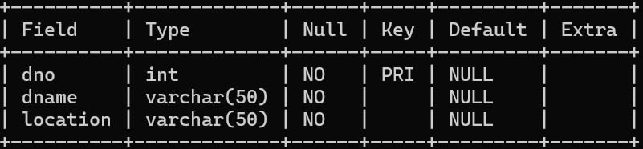

**mysql>** Insert into dept values(101,'Computer','Pune'), (102,'Statistics','Mumbai'),

(103,'Quality','Satara'),(104,'Finance','Pune'),(105,'Computer','Mumbai'); **mysql>** Select * from dept;

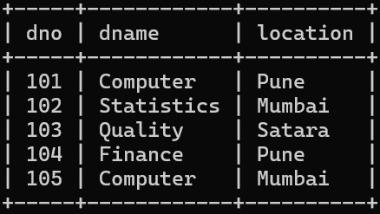

**mysql>** Create table employee(eno int primary key,ename varchar(100) Not Null,designation varchar(50),salary float check(salary>0),date_of_joining date, dno int references dept(dno)); **mysql>** desc employee;

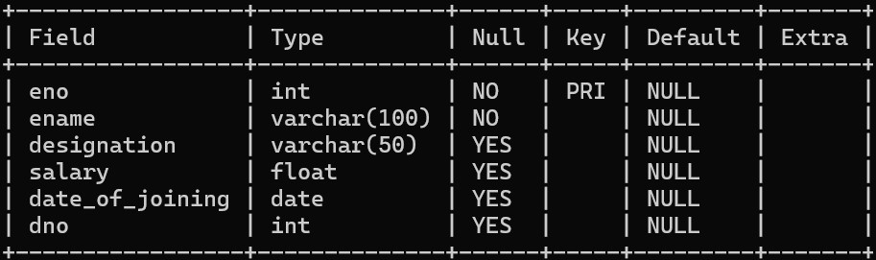

**mysql>** insert into employee values(1,'Mr.Advait','Assistant',54000,'2002-03-23',104),

(2,'Mr.Roy','ceo',50000,'2019-06-15',102), (3,'Mr.Abhay','manager',60000,'2013-06-10',102), (4,'Mr.Raghav','manager',42000,'2003-03-01',103), (5,'Mr.Ram','CEO',400000,'2000-12-12',101); **mysql>** select * from employee;

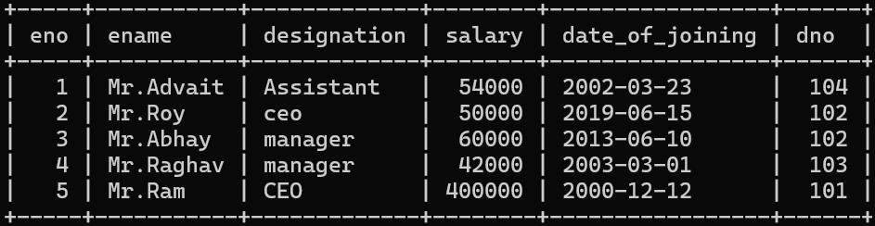

1. **Add column phone_No into the Employee table with data type int.**

**mysql >** Alter table employee add column phone_no int; **mysql >** desc employee;

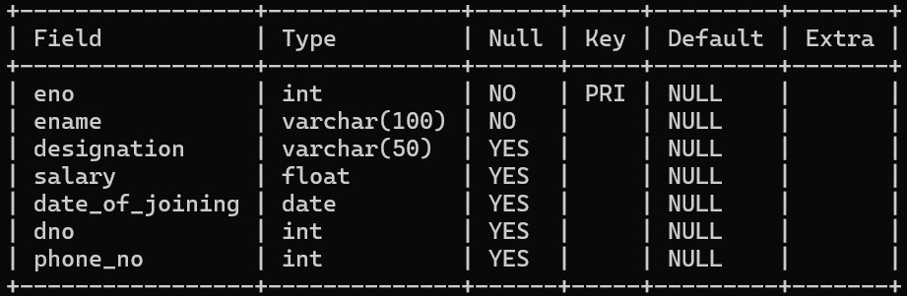

1. **Update phone_no column mysql>** update employee set phone_no=786590987 where eno=1; **mysql>** update employee set phone_no=896691967 where eno=2; **mysql>** update employee set phone_no=967397851 where eno=3; **mysql>** update employee set phone_no=730373965 where eno=4; **mysql>** update employee set phone_no=877396678 where eno=5; **mysql>** select * from employee;

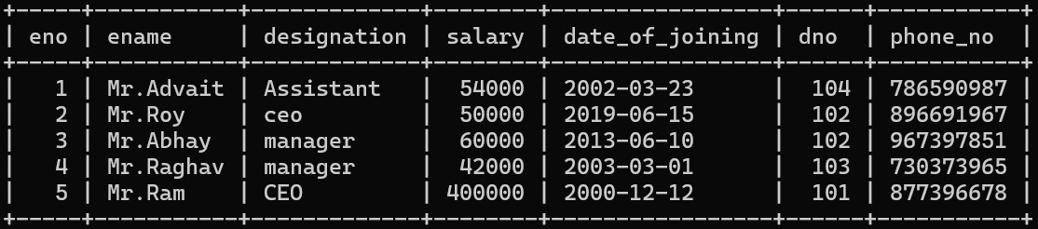

1. **Delete the details of Employee whose designation is ‘Manager’. mysql>** Delete from employee where designation=’Manager’.
2. **Display the count of employees department wise. mysql>** select count(eno)as Total_Employee_Depatement_Wise,dname from employee,dept where employee.dno=dept.dno group by dname;

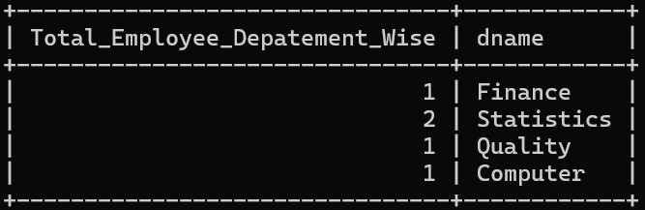

1. **Display the name of the employee who is ‘Manager’ of the “Account” Department.**

**mysql>** select ename from employee,dept where employee.dno=dept.dno and designation='Manager' or dname='Account';

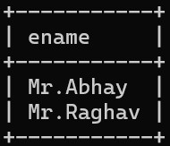

1. **Display the name of department whose location is “Pune” and “Mr. Advait” is working in it.**

**mysql>** select dname from dept,employee where dept.dno=employee.dno and location='Pune' and ename='Mr.Advait';

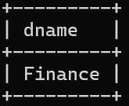

1. **Display the names of employees whose salary is greater than 50000 and the department is “Quality”.**

**mysql>** select ename from employee,dept where employee.dno=dept.dno and salary>50000 and dname='Quality'; **Empty set (0.00 sec)**

1. **Update Dateofjoining of employee to ‘15/06/2019’ whose department is ‘computer science’ and name is “Mr. Roy’.**

**mysql>** update employee,dept set date_of_joining='2020-07-10' where employee.dno=dept.dno and dname='Computer' and ename='Mr.Roy'; **Query OK, 0 rows affected (0.00 sec) Rows matched: 0 Changed: 0 Warnings: 0**

# Task 2

**mysql>** create table client(clientNo int primary key,clientName varchar(100) Not Null,address varchar(50) Not Null); **mysql>** desc client;

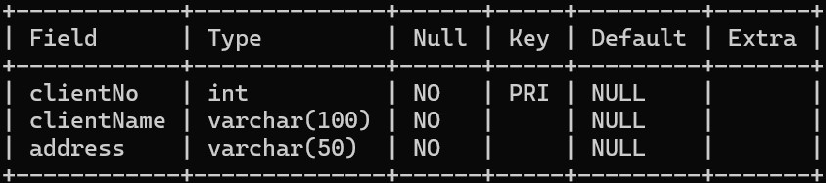

**mysql>** INSERT INTO client (clientNo, clientName, address) VALUES

-> ('CN001', 'Mr.Ram', 'Pune'),

-> ('CN002', 'Mr.Raghav', 'Satara'),

-> ('CN003', 'Mr.Roy', 'pimpri'),

-> ('CN004', 'Mr.Nilesh', 'Mumbai'),

-> ('CN005', 'Mr.Tushar', 'Solapur'); **mysql>** select * from client;

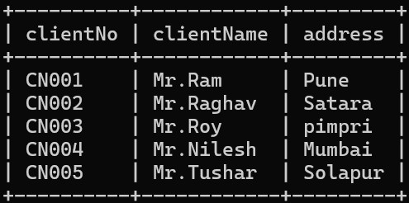

**mysql>** create table sales_order(ordNo int primary key,ordDate date Not Null,sale_order varchar(100) Not Null,clientNo varchar(50) references client(clientNo)); **mysql>** desc sales_order;

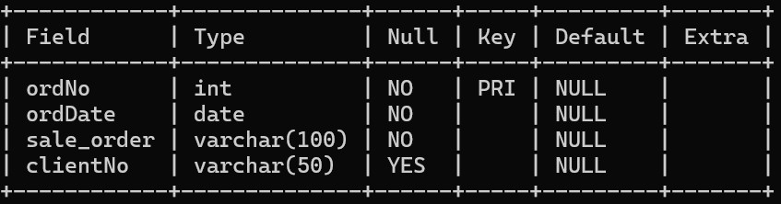

**mysql>** INSERT INTO sales_order (ordNo, ordDate, sale_order, clientNo) VALUES

-> (1, '2019-03-18', 'Laptop', 'CN001'),

-> (2, '2024-07-02', 'Pizza', 'CN002'),

-> (3, '2024-07-03', 'Bag', 'CN003'),

-> (4, '2022-01-22', 'Mobile', 'CN004'),

-> (5, '2002-01-31', 'Watch', 'CN005'); **mysql>** select * from sales_order;

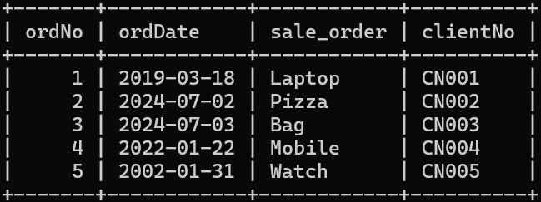

1. **Add column amount into sales_amt table with data type float.**

**mysql>** alter table sales_order add column sale_amt float; **mysql>** select * from sales_order;

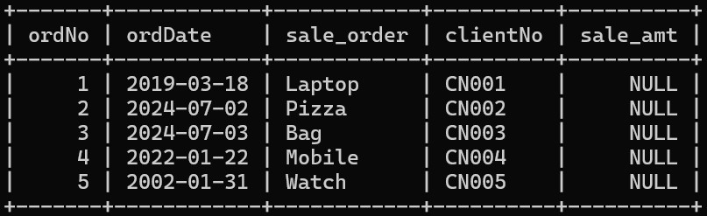

1. **Delete the details of the clients whose names start with ‘A’ character. mysql>** delete from client where clientName Like 'A%'; **Query OK, 0 rows affected (0.00 sec)**
2. **Delete sales order details of a client whose name is “Patil” and order date is “09/08/2019”.**

**mysql>** DELETE FROM sales_order WHERE clientNo IN ( SELECT clientNo FROM client WHERE clientName = 'Patil') AND ordDate = '2019-08-09'; Query OK, 1 row affected (0.01 sec) **mysql>** select * from sales_order;

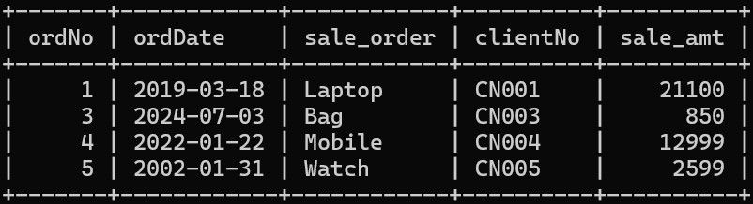

1. **Change the order date of client_No ‘CN001’ ‘18/03/2019’. mysql>** update client,sales_order set ordDate='2019-12-31' where

client.clientNo=sales_order.clientNo and client.clientNo='CN001' and ordDate='2019-03-18'; **mysql>** select * from sales_order;

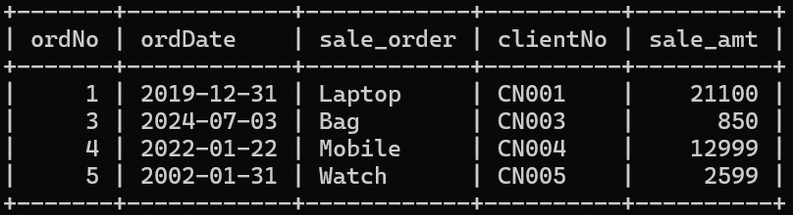

1. **Delete all sales_record having an order date is before ‘10 /02/2018’.**

**mysql>** delete from sales_order where ordDate='2018-02-10'; **Query OK, 0 rows affected (0.00 sec)**

1. **Update the address of client to “Pimpri” whose name is ‘Mr. Roy’. mysql>** update client set address='pimpri' where clientName='Mr.Roy';

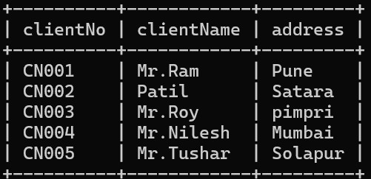

1. **display totals orders between 1jan2022 to 31 jan 2022.**

**mysql>** select count(ordNo) from sales_order where ordDate Between '2022-01-01' and '2022-01-31';

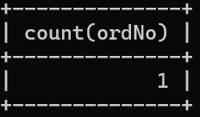

1. **display totals sale amount between 1jan2022 to 31 jan 2022.**

**mysql>** select sum(sale_amt) from sales_order where ordDate Between '2022-01-01' and '2022-01-31';

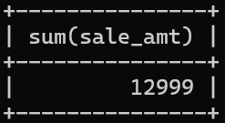

1. **display total no of customers from pune location.**

**mysql>** select count(clientNo) from client where address='pune';

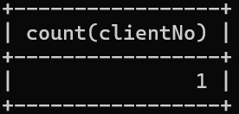

# Task 3

**mysql>** Create table hospital(hno int primary key,hname varchar(50) Not Null,city varchar(50)

Not Null,Est_year int,addr varchar(50));

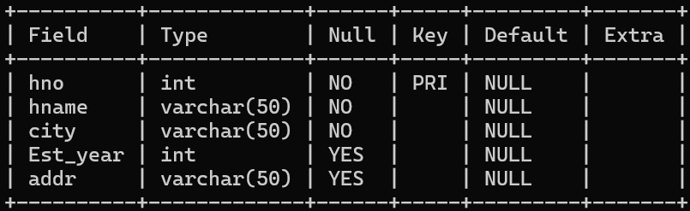

**mysql>** insert into hospital values(1,'City Hospital','Pune',1990,'Pune'),(2,'Apollo

Hospital','Mumbai',1983,' '),(3,'CNS','Solapur',2017,'Soalpur'),(4,'Mauli Hospital','Satara',2014,'Satara'),(5,'Fortis Hospital','Delhi',1996,'Delhi');

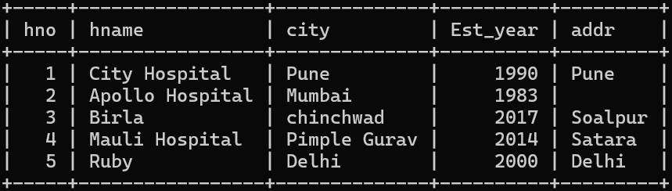

**mysql>** Create table doctor(dno int primary key,dname varchar(100) Not Null,addr varchar(100) Not Null,speciality varchar(100) Not Null,salary float check(salary>0),hno int references hospital(hno));

**mysql>** desc doctor;

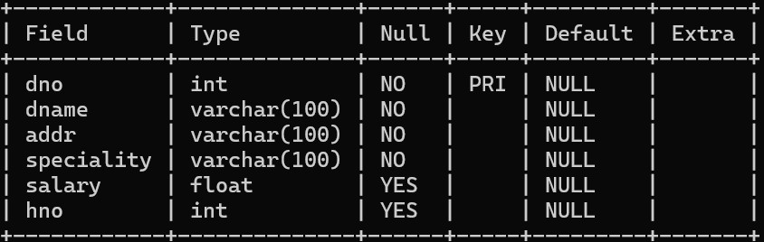

1. **Delete addr column from Hospital table.**

**mysql>** Alter table hospital drop addr; **mysql>** desc hospital;

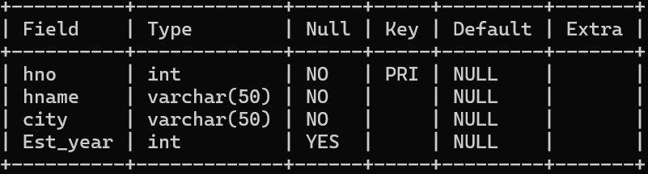

1. **Display doctor name, Hospital name and specialty of doctors from “Pune City” . mysql>** SELECT doctor.dname, hospital.hname, doctor.speciality FROM doctor, hospital

WHERE doctor.hno = hospital.hno AND hospital.city = 'Pune';

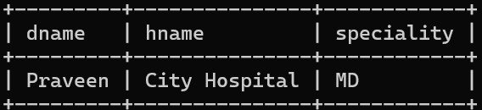

1. **Display the names of the hospitals which are located in “Pimpri” city.**

**mysql>** select hname from hospital where city='pimpri'; **Empty set (0.00 sec)**

1. **Display the names of doctors who are working in “Birla” Hospital and the city name is “Chinchwad”.**

**mysql>** select doctor.dname from doctor,hospital where doctor.hno=hospital.hno and hospital.hname='Birla' and hospital.city='chinchwad';

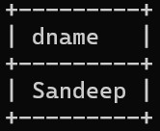

1. **Display the speciality of the doctors who are working in “Ruby” hospital. mysql>** select speciality from doctor,hospital where doctor.hno=hospital.hno and hospital.hname='Ruby';



1. **Give the count of doctor’s hospital wise which are located at “Pimple Gurav”. mysql>** select count(dno) as doctor_count,hname from doctor,hospital where doctor.hno=hospital.hno and hospital.city='pimple gurav' group by hospital.hname;

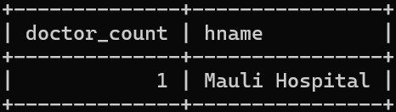

1. **Update the address of the Doctor to “Pimpri” whose hospital is “Ruby clinic”. mysql>** update doctor,hospital set addr='Pimpri' where doctor.hno=hospital.hno and hname='Ruby' ; **mysql>** select * from doctor;

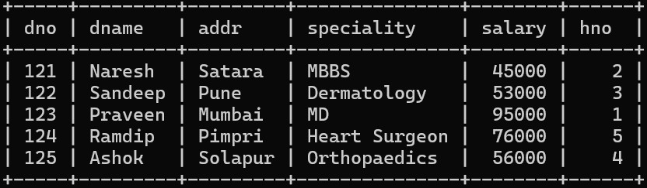

1. **display doctor details whose speciality is Heart Surgeon and who belong to a hospital from pune.**

**mysql>** select * from doctor,hospital where doctor.hno=hospital.hno and doctor.speciality='Heart Surgeon' and hospital.city='Pune'; **Empty set (0.00 sec)**

1. **Update the address of the hospital to “Pimpri” whose hospital was established in “2000”. mysql>** update hospital set city='Pimpri' where Est_year=2000; **mysql>** select * from hospital;

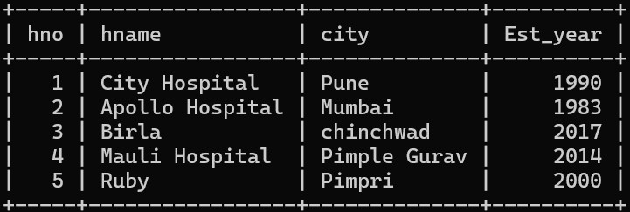

1. **Display Total salary of all doctors hospital wise. mysql>** select sum(salary) as Salary_Sum, hname from doctor,hospital where doctor.hno=hospital.hno group by hospital.hname;

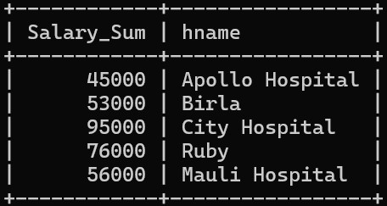

1. **Display the annual salary of a doctor who lives in Pune. mysql>** select salary*12 as Annual_Salary from doctor where addr='Pune';

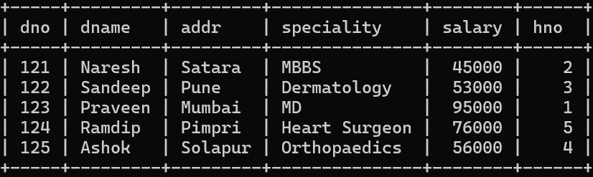

# Task 4

**mysql>** Create table department(dno int primary key,dname varchar(100),HOD varchar(100),loc varchar(50)); **mysql>** desc department;

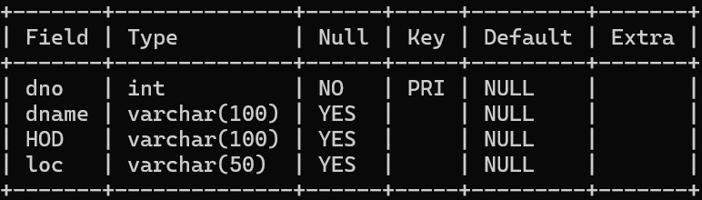

**mysql>** insert into department values(1, 'Research','Mr.Desai','Pune'),(2,

'Development','Mr.Sham','Mumbai'), (3, 'Marketing','Mr.Yash','Satara'),(4,

'Statistic','Mr.Shah','Kolhapur');

**mysql>** Create table project(pno int primary key,pname varchar(100) Not Null,start_date date,budget float,status varchar(100),dno int references department(dno)); **mysql>** desc project;

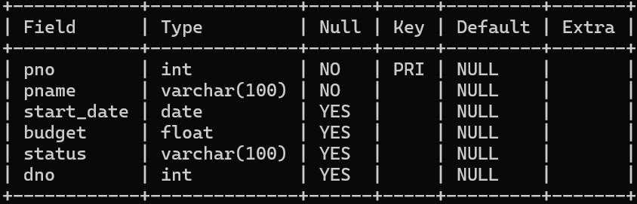

**mysql>** Insert into project values(101, 'Student Management',

'2023-01-01',20000,'Progressive',2), (102,'Currency Converter', '2024-11-21', 5000, 'Completed', 4), (103,'Snake Game','2024-07-28',15000,'Active',1),(104,'ATM System', '2024-06-03', 120000,

'Completed',3); **mysql>** select * from project;

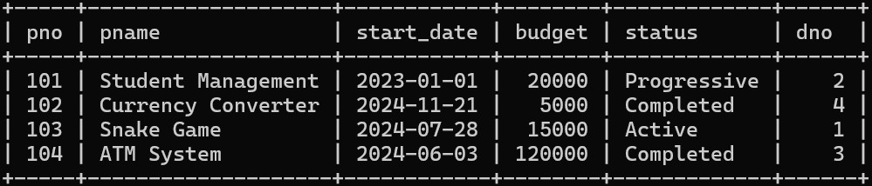

1. **Drop loc column from department table.**

**mysql>** Alter table department drop loc; **mysql>** desc department;

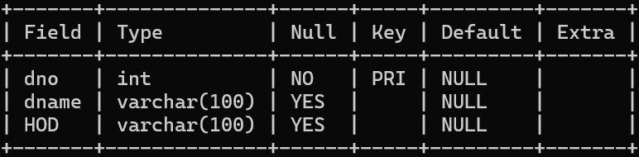

1. **Display the details of projects whose start_date is before one month and status is “Progressive” . mysql>** Select * from project where start_date<CURRENT_DATE - INTERVAL 1 MONTH and

status='Progressive';

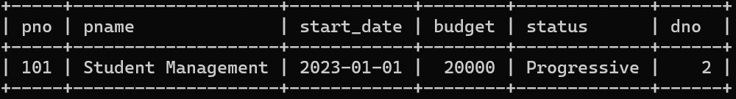

1. **Display the names of projects and departments who are working on projects whose status is ‘Completed’. mysql>** select pname,dname from project,department where project.dno=department.dno and project.status='Completed';

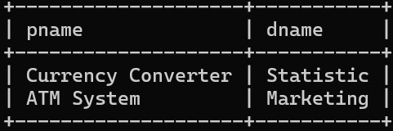

1. **Display total budget of each department. mysql>** Select sum(budget),dname from project,department where project.dno=department.dno group by dname;

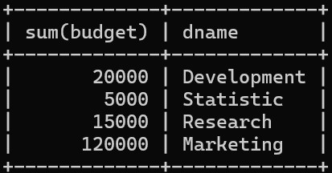

1. **Display incomplete projects of each department. mysql>** select pname,dname from project,department where project.dno=department.dno and status IN('Progressive','Active') group by dname,pname;

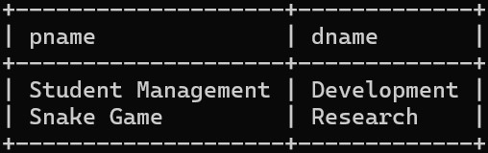

1. **Display all project working under 'Mr.Desai'. mysql>** select pname from project,department where project.dno=department.dno and department.HOD='Mr.Desai';



1. **Display department wise HOD.**

**mysql>** select HOD,dname from project,department where project.dno=department.dno group by dname,HOD;

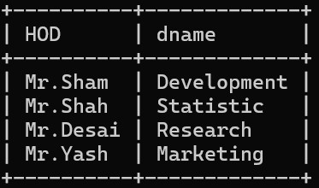

1. **Display project details where the project name starts with A and whose budget is >10000 in descending order. mysql>** Select * from project where pname Like 'A%' and budget>10000 order by pno desc;

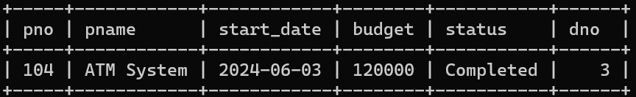

1. **Display the project details which have the highest budget.**

**mysql>** select * from project where budget=(select Max(budget) from project);

